***List of Potential Improvements:***

1. Allow an end call button during video chat
2. Make sure all buttons are functioning
3. Make a help button to guide through app
4. Make the flow of app usage more fluid & user friendly (it’s kind of difficult to know what you’re supposed to do right off the bat with how it’s set up)
5. Workout scheduling system based on persona-Charles, need to distinguish between time of day of working out
6. Motivational pop up messages, based on persona-Janine
7. Limit max number of people on the call
8. Have a color theme/logo with one cohesive look
9. Pop ups to communicate that you’re going to be video calling someone
10. Favorite exercise, which is automatically included in all regimens

***Figma Changes:***

Usability Improvements:

1. Make sure all buttons are functioning
2. Make a help buttons to guide through app- note did not add information for contacts the action of adding a contact because we believe it is pretty self explanatory
3. Scheduling system

***Visual Refresh:***

Visual Improvements:

1. Color theme with logo (create logo)
2. Change shape of buttons to match each other in terms of action when clicked- visual similarity
3. Contrast colors of the back button with the rest of UI, so the user never feels trapped in a certain screen.

***Images Showing Changes:***

Before: <https://www.figma.com/file/IV1t3Etw8E4PrlBeB0Xcwi/Prototype?node-id=0%3A1>

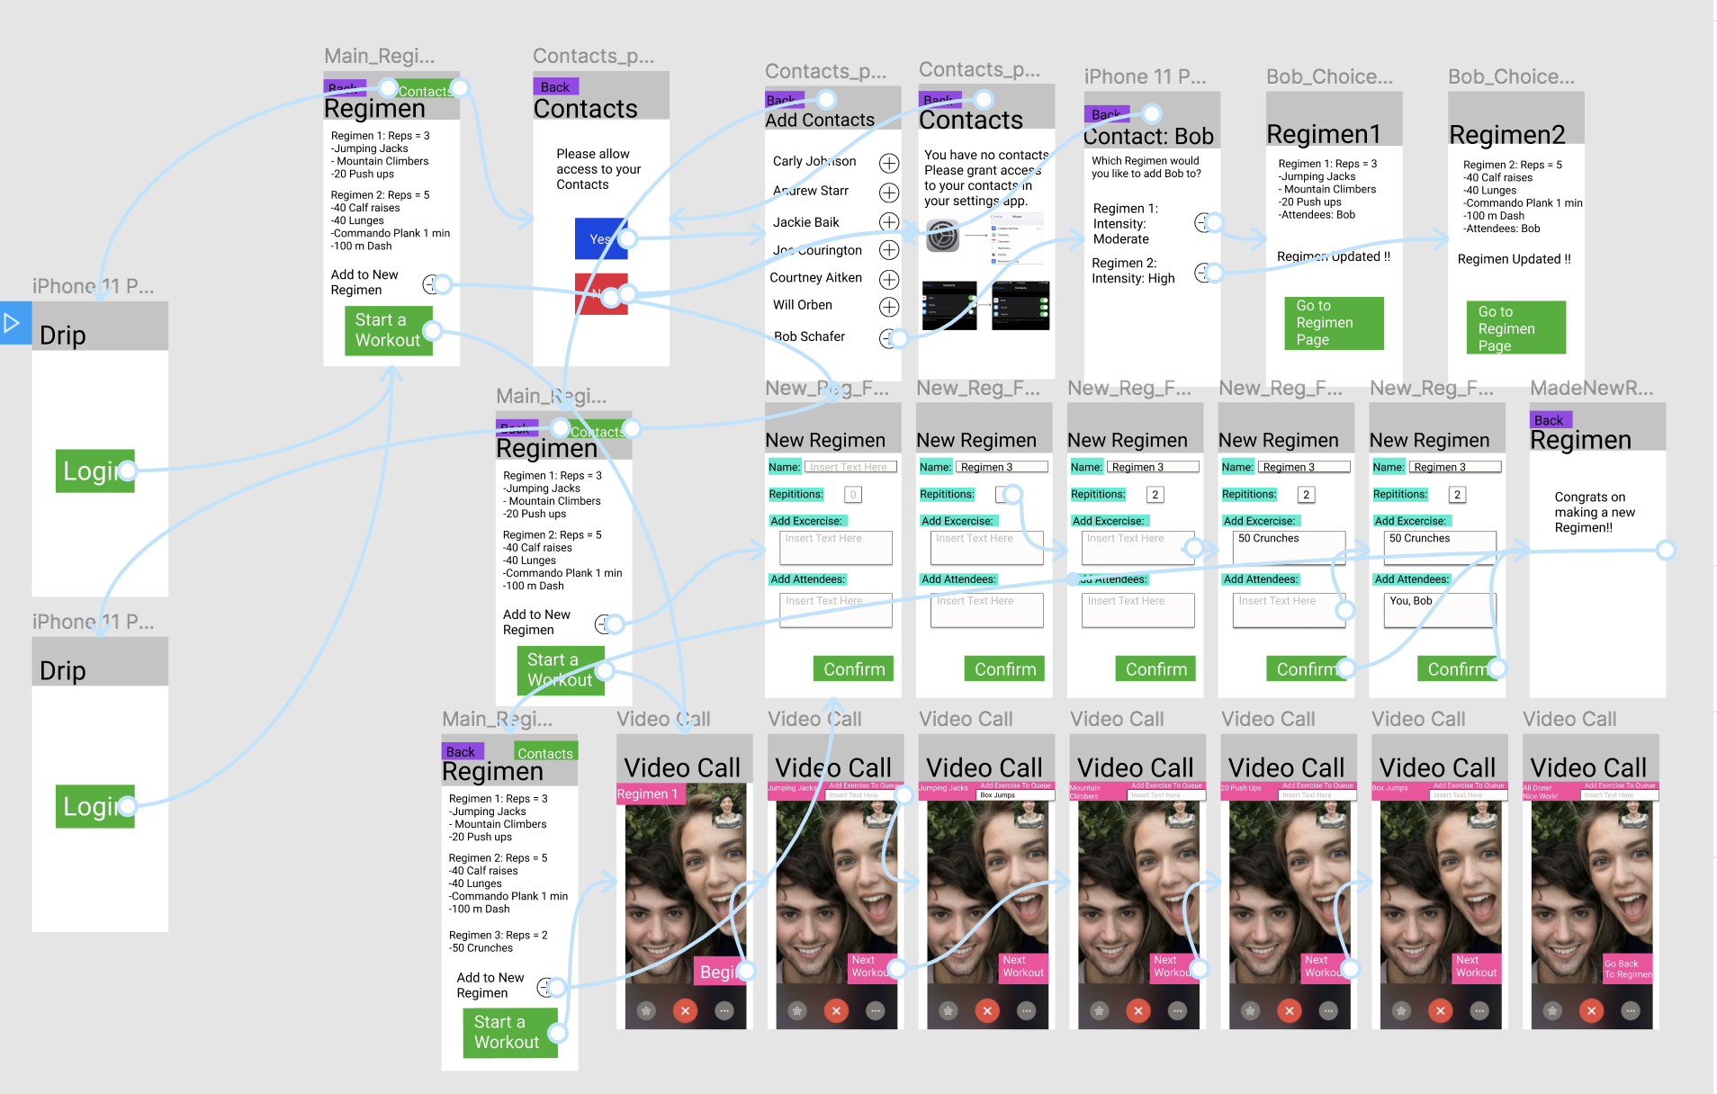

After: <https://www.figma.com/file/A2MvJI5fmOuXWweSbEgG2G/Prototype2?node-id=0%3A1> 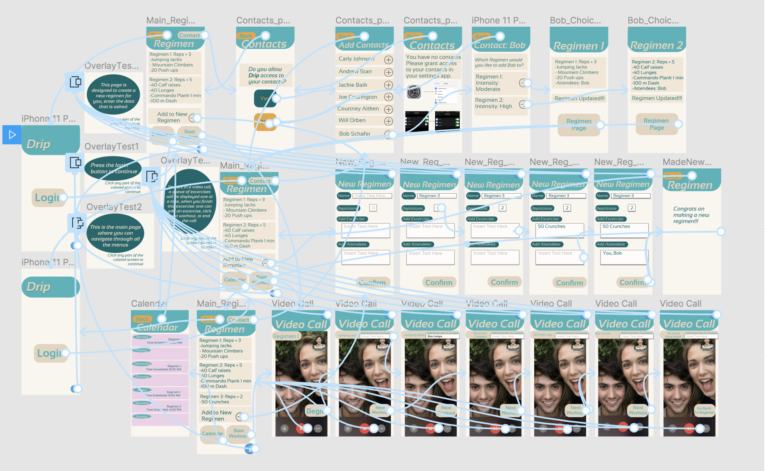

Prototype: <https://www.figma.com/proto/A2MvJI5fmOuXWweSbEgG2G/Prototype2?node-id=2%3A4&scaling=scale-down>